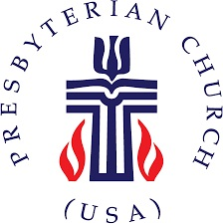
The Presbytery of Northern Waters
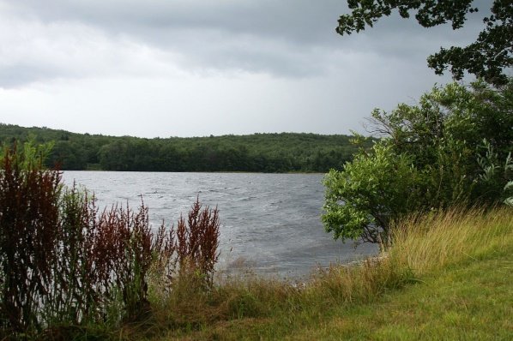

PRESBYTERY MEETING HIGHLIGHTS

The Presbytery of Northern Waters held its Winter Stated Meeting at the United Presbyterian Church, Superior on Saturday, February 1, 2020. The weather, fortunately, was conducive to traveling to Superior from across the Presbytery. There were 55 people in attendance for our meeting and were warmly welcomed by members of the host church.

Vice Moderator Dorothy Duquette conducted a brief orientation for first-time commissioners. We plan to continue this tradition so that new commissioners have a better chance to understand what goes on at the Presbytery Meeting. We did have one first-time pastor members of the Presbytery: Cheryl Fleckenstein, an ELCA pastor serving the Grand Rapids church as Interim Head of Staff. We also celebrated 3 first-time Ruling Elder Commissioners.

The featured speaker was Elona Street Stewart, the Synod Executive for the Synod of Lakes and Prairies. This is the synod of which Northern Waters is a member along with 15 other presbyteries. Before becoming Synod Executive 5 years ago, Elona served for over 20 years as the Synod’s program staff person for racial ethnic ministries and community empowerment. Her topic this day was Indigenous Empowerment, Resilience, and Healing, speaking about current American Indian values, practices and achievements. Elona is the first and only Native American Synod Executive in the Presbyterian Church (U.S.A.). She is also a candidate this year for Co-Moderator of the General Assembly.

The Committee on Ministry (COM), plans to write a letter encouraging all pastors and Ruling Elders to live by their ordination vows to participate in the governance of the more inclusive Councils of the church, particularly the Presbytery. Attendance by both pastors and commissioners of the churches needs to improve. For example, of more than 54 minister members of the Presbytery, only 21 attended this meeting and of 49 churches in the Presbytery only 17 were represented by Ruling Elders. COM will also be requesting that all churches share with the Presbytery contact information lists for those currently serving on Sessions and encourage sharing their full member ship lists and contact information.

The Overtures and Bylaws Committee (O&B) recommended approval (and the Presbytery approved) of an addition to the Manual of Operations to establish a procedure for grants to be made from the Presbytery’s largest fund, the Church Development Fund.

O&B also recommended approval of the request of the Session of the First Presbyterian Church, Eau Claire, to concur in two overtures (initiated by other presbyteries) to this year’s General Assembly: one regarding gun violence and the other regarding divestiture of the church’s investments from companies involved in fossil fuels. Both recommendations were approved after much discussion.

Treasurer Jay Wilkinson, spoke to the year-end financial statements and to the written report submitted by Finance & Budget Committee Chair, Bill Gravelle. We ended the year with a small surplus just over $1,000 compared to a budgeted deficit of $11,441. The primary reason is due to the better than forecast performance of investments in 2019.

The merger of the Wrenshall and Carlton churches is nearing completion, as reported by the Rev. Joel Huenemann, chair of the Administrative Commission. The Administrative Commission dealing with the closing of the Warba church reported that the building has been sold. The Presbytery dismissed the Commission, with thanks for their dedication to these tasks.
Those who will be attending the Presbytery sponsored trip to work with Presbyterian Disaster Assistance (PDA) were commissioned to their tasks. The Presbytery has sponsored these work trips for a number of years, thanks in large part to the dedication of the Rev. Rich Blood to promote and organize the trips. This year’s trip is to Louisiana, and they will be leaving on February 15.

Any of the reports from the meeting can be sent to you by contacting either Jay Wilkinson (j.jay.wilkinson@gmail.com) or Amanda at the Presbytery office (office@northernwaters.net) or by calling the Presbytery office (715-394-6265).

Next meeting: Thursday, May 7, 2020 at the First Presbyterian Church, Bayfield, WI. Hope to see you there.

