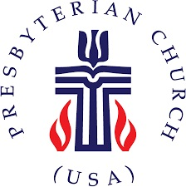
The Presbytery of Northern Waters
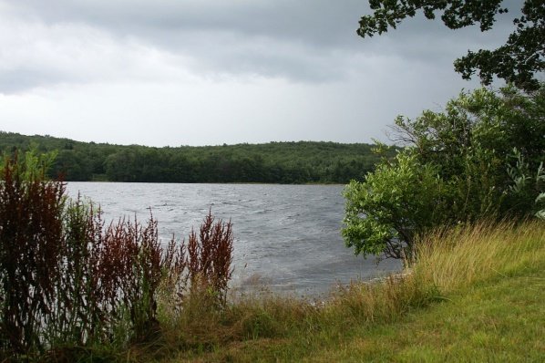

PRESBYTERY MEETING HIGHLIGHTS

The Presbytery of Northern Waters held its Fall Stated Meeting at Presbyterian Clearwater Forest on Friday and Saturday, October 26-27, 2018, 2018. The weather was gray, cold and rainy, but the climate in the meeting was warm and inviting There were about 53 people in attendance for our meeting.

The featured speaker was the Thomas E. Boomershine, professor of New Testament at United Theological Seminary in Dayton, Ohio. He is founder of the Network of Biblical Storytellers. He presented a program in several pieces on Biblical Storytelling. Storytelling has some characteristics of performance art and is a way of entering into the original character of the Bible. Early on, people did not read the Bible but heard it spoken from memory. Tom led the presbytery in how to make a difference by “telling” and not just reading scripture. If people pay better attention to the scripture it can help the congregation to better understand and apply the sermon to their lives. The fact that there are four Gospels in the Bible is a testament that storytelling was an important part of the early church.

Ruling Elder Mary Voss, Superior United, was elected Moderator. Mary has been Vice-Moderator this past year. The Reverend Chris McCurdy, pastor at the Rice Lake church, was elected Vice-Moderator. The Reverend Rich Blood, this past year’s Moderator moves to chair of the Presbytery Council for this next year (not elected but directed by the Bylaws).

Many other positions on committees were elected, but we still have a number of openings and encourage all to volunteer or suggest names of others to fill these positions. We hope to have more people elected to committees at the February meeting.

The Committee on Ministry has approved a contract between the Reverend Mary Marotte and the Park Rapids church. Mary is an ELCA pastor learning to minister and work with Episcopalians and Presbyterians. The call of the Reverend Lawrence Lee to the Bayfield church was also approved to be effective September 1. Lawrence has previously served in positions within Northern Waters but has recently served a church in Whitewater Valley Presbytery.

The Presbytery approved updated minimum salary standards for 2019 as recommended by the Committee on Ministry. The details will be sent to the churches soon, along with per capita statements for 2019.

A merger between the Solon Springs and the Gordon congregations within Pioneer Parish was approved and an Administrative Commission was approved to guide them through the details.

The Presbytery approved the commissioning of Ruling Elders Henry (Chip) Holt (Bemidji), Katie Larson (Hibbing), and Mary Shideler (Grand Rapids). They were commissioned during the Friday evening worship service

The Finance and Budget Committee presented the recommendation of the 2019 budget. This budget calls for per capita apportionment totaling $32.00 for each member as of 12/31/2017. This is an increase of $1.50 per member including an increase from the General Assembly of $1.22. The recommended allocation of mission contributions will be 20% to GA, 10% to the Synod, and 70% to the Presbytery. The budget includes a projected $11,440 deficit which will be made up primarily by our history of not spending every budgeted dollar. The Presbytery approved the budget. For the first 9 months of 2018, the Presbytery is showing a surplus of $12,126 compared to a surplus of $32,818 at this time last year. The primary difference is the addition of the Pastoral Care position now provided by the Reverend Ken Ribe.

The Program Strategy Committee brought to the attention of the Presbytery that the Youth Triennium is scheduled for about one year from now (July 16-20, 2019) at Purdue University. Sandy Uttley from the Lakeside Presbyterian Church has once again agreed to spearhead participation by the youth from Presbytery of Northern Waters churches. Sandy may be contacted at sandy@lakesidepreschurch.org.

Reverend Rich Carloss indicated that he is once again organizing a PDA mission trip in the coming months, likely to North Carolina. Please contact him at reblood@msn.com for details as they are finalized.

Any of the reports from the meeting can be sent to you by contacting either Jay Wilkinson (j.jay.wilkinson@gmail.com) or Ann at the Presbytery office (office@northernwaters.net) or by calling the Presbytery office.

Next meeting: Saturday, February 2, 2019 at Lakeside Presbyterian Church, Duluth, MN. We hope to see you there.

