STATED MEETING
OF THE PRESBYTERY
OF NORTHERN WATERS
OCTOBER 9, 2020
VIA ZOOM

Moderator, Chris McCurdy, called the Stated Meeting of the Presbytery of Northern Waters to order at 10:08 a.m. on Friday, October 9, 2020. He opened the meeting with prayer.

Stated Clerk, Brad Carloss, declared a quorum.

The Stated Meeting Docked was amended to move the presentation time of William McConnell; Mission Engagement Advisor, Central Region, Presbyterian Mission Agency; to 10:30 a.m. instead of the slated time of 11:30. This moved COM, Finance and Budget, and Nominating Committee’s times 30 mins.
The Presbytery approved the Stated Meeting Docket as amended which included the Consent Agenda.

Report of the Stated Clerk
Brad Carloss, Stated Clerk

- The Presbytery approved the motion that today’s meeting will be via zoom and that votes, made by button clicking or hand raising, in this meeting are, therefore, official votes of the Presbytery.
See Figure 1: Approved “Norms and Standing Rules for Zoom Presbytery Meetings”
- The Presbytery approved the motion that the following Corresponding Members be seated:
- Brian Schroder – Director of Emerging Worship, Lord of Life Lutheran Church, Maple Grove, MN, ELCA
- Rev. Tyler Sit – New City Church, South Minneapolis, MN, Methodist
  - William McConnell – Mission Engagement Advisor, Central Region, Presbyterian Mission Agency.
- The Presbytery approved the motion of the Appointment of staff member, Amanda Keppers, as the Roll Clerk and Minutes Clerk.
- The roll, formed from the participants list of zoom, follows:
Teaching Elders- Minister Members
Matthew Arneson | P |  | Lawrence Lee | P
Lindsay Louise Biddle |  |  | Elizabeth Liebentstein
Richard Blood | P |  | James "Chris" McCurdy | P
James Deters | P |  | Chips Paulson | P
Dorothy Duquette | P |  | Kerry Tomhave
Corey Larsen | P |  | Kathryn Reid Walker | P
Brett Foote | P |  | Lon Weaver
Kari Jutila | P |  | Robyn Weaver | P
Jeremiah Knabe | P |  | Douglas Workman | P
Kate Kolmodin | P |  | John Yingling
Corey Larsen | P
Honorably Retired
Duane Aslyn |  |  | David Guthrie
Dianna Bell |  |  | Janelle Harrison
Donald Bell |  |  | Ron Henely
Barry Boyer | P |  | Robert Hickman
Don Bump |  |  | Charles House
Bruce Calbreath |  |  | Joel Huenemann
Bradley Carloss | P |  | Sharon Johnson
B. Colquhoun |  |  | Robert Light
Martha Coltvet |  |  | John Mann | P
Peggy Cooper |  |  | Cindy Martinson, CRE | P
Frank Davis |  |  | Eric Nielsen
Nancy Deever |  |  | Ken Ribe | E
John D. Gibbs | P |  | Darrel Robertson
John G. Gibbs |  |  | Kate Stangl | P
Robert Goodin | P |  | C. Arlin Talley | P
Susan Goodin |  |  | Roger Waid
Temprary Relationship Teaching Elders
Bill Chadwick |  |  | Rick Mann
Ray Cole |  |  | Carolyn Mowchan
Cheryl Fleckenstein | P |  | Don Nickolson
Paula Gaboury | P |  | Paul Scaringi
Aaron Lofgren
Commissioned Ruling Elders
Leslie Anderson | P |  | Katie Larson
Deb Emery |  |  | Sharron Lewis
Jack Fashbaugh |  |  | Mary Shideler
Chip Holt | P |  | Beverly Thompson
Churches: Ruling Elders
Ashland-Presbyterian-Congregational
Babbitt-Woodland
Bayfield-Bayfield
Bemidji-First
Bigfork-First
Bigfork-Bowstring
Blackduck-First
Bovey-Lawron |  |  | Joan Beech | P
Brule-Brule
Calumet-Community |  |  | Peggy Smith | P
Carlton-River’s Edge |  |  | Carol Ankrum | P
 |  |  | Judy Tribby | P
Chippewa Falls-First |  |  | Lynda Butek | P
Cloquet-Presbyterian Church of Cloquet |  |  |  | E
Coleraine-First United |  |  | Candy Deal | P
Cornell-First
Duluth – First
Duluth-Glen Avon |  |  | Claudia Welty | P
Duluth-Lakeside |  |  | David Uttley | P
Duluth-Pike Lake
Duluth-Westminster |  | Paul Rigstad |  | P
Eau Claire-First |  |  | Timothy Nieman | P
Eau Claire-North
Ely-First |  |  | Jean Gendreau | P
Grand Rapids-Community
Hannibal-New Hope
Hibbing-First
Hurley-First
Iron River-Calvary
Ironwood-First
Keewatin-Cong. of the Good Shepherd
Lac du Flambeau-Community
Lake Nebagamon-First
Manitowish Waters-Community
McGrath-Calvary
McGregor-Round Lake
Park Rapids-Trinity
Phillips-First |  |  | Angela Michler | P
St. Croix
Rice Lake-United
Silver Bay-United Protestant
Superior- Country Peace
Superior-Pioneer Parish | Linda Rice-St. John |  | P
Superior-United |  |  | Cameron Campbell | P
 |  |  | Jim Willmore | P
Tamarack-First
Tower- St. James
Two Harbors-United |  |  | Darlene Graden | P
Virginia-Hope Community
Wahkon-McGrath
Willow River-First
Winter-First
Wrenshall-First
Corresponding Members
William McConnell | P
Brian Schroder | P
Tyler Sit | P
Council Members (Those not accounted for elsewhere)
Gary Cross, RE, COM | P |  | Cathy Hecht, Synod | P
Hope Daughtery, PW | P |  | Mary Voss, Chair | P
Bill Gravelle, F&B | P
Staff
Amanda Keppers, Minutes Clerk |  | P
Jay Wilkinson, Resource Person, Host |  | P

Consent Agenda
Chris McCurdy, Moderator
- Brett Foote was recognized and requested that the GA report from the 2020 YAAD be entered into the minutes of the “Consent Agenda.” See Figure 2: 2020 GA YAAD Report for the report submitted by Kate Lisak.
- Paul Rigstad was recognized and requested attention be drawn to section “H. Report from Presbyterian Clearwater Forest (Consent Agenda).”
- The Presbytery moved and approved the Consent Agenda as written. See Figure 3 – Figure 12: Consent Agenda pages 1 - 10 for the “Consent Agenda”.
Special Announcements
Brad Carloss, Stated Clerk
- Included everything said about the agenda, working together, being patient with one another, and trying to listen and deal with the technology as we continue to experiment with it.
- Jay is acting as host at the meeting. He will be clearing the votes and monitoring the meeting.

Matthew 25 Churches
Presented by:
William McConnell, Mission Engagement Advisor,
Central Region, Presbyterian Mission Agency
- William McConnell is a Ruling Elder from Highland Presbyterian Church in Louisville, Kentucky. He has been the Mission Engagement Advisor of the Central Region for the Presbyterian Mission Agency for four years. His region covers three Synods. William describes his position as a Mission Engagement Advisor as being a thanker, connector, brainstormer, translator, and helper.
- As a thanker William McConnell took the time to thank our Presbytery for the following:
  - Matthew 25 Churches
    - Community Presbyterian Church of Grand Rapids, MN
    - United Church of Two Harbor of Two Harbors, MN
    - First Presbyterian Church of Eau Claire, WI
    - First United Presbyterian Church of Willow River, MN
- 4 of 4 Churches (those who received all four PC(USA) Special Offerings in 2019)
  - Bayfield Presbyterian Church of Bayfield, WI
  - Brule Presbyterian Church of Brule, WI
  - First Presbyterian Church of Bemidji, MN
  - First Presbyterian Church of Chippewa Falls, WI
  - Lakeside Presbyterian Church of Duluth, MN
  - Glen Avon Presbyterian Church of Duluth, MN
  - First Presbyterian Church of Eau Claire, WI
  - Country Peace Presbyterian Church of Superior, WI
  - Presbytery of Northern Waters
  - First United Presbyterian Church of Willow River, MN
- Presbyterian Giving Catalog
  - Brule Presbyterian Church of Brule, WI
  - Trinity Episcopal Church of Park Rapids, MN
  - United Presbyterian Church of Superior, WI
  - St. James Presbyterian Church of Tower, MN
- The Presbytery of Northern Waters shared Mission total over the last 10 years
      - $331,516 out of $1,122,915
- The mission that William McConnell was presenting was “Matthew 25”. Matthew 25 comes from verses 31-36. It was developed to bring churches together rather than continue fighting. The origin and practice of Matthew 25 churches are: dismantling structural racism, eradicating systemic poverty, and building congregational vitality. There are three main focuses of Matthew 25. The first is structural racism/white privilege. This focus aims to dismantle laws, policies, and practices that structure, reinforce, and perpetuate discrimination, bias, prejudice, and oppression of people of color. The second is systemic poverty. This focus aims to eradicate the exploitation of people who are poor through laws, policies, practices, and systems that perpetuate an impoverished status. The third is congregational vitality. This focus aims intentionally and continuously develop in faith and actively engage the community. Changing the churches ABC’s from attendance, building, and cash to awareness, bravery and call. The purpose of Matthew 25 churches is to connect and unite the PC(USA), celebrate and call forth, and clarify the self-understanding of Christians in the PC(USA). As of today, 637 congregations, 46 Presbyteries, 5 Synods (including Lakes and Prairies), and 24 others have become Matthew 25 churches. For more information, resources, presentations, or to enroll your church; visit www.pcusa.org/matthew25.
- In closing, William McConnell asked that we pray for the Presbyterian Mission, engage with questions, and support them when looking at our budgets.
- The Moderator opened the floor for questions and comments.
    - Cameron, RE of UPC, Superior requested that the slide show be shared. William McConnel agreed to make the slideshow minus the videos available.
    - Joan Beech, RE of Lawron, Bovey, MN asked to make a statement. “I’d just like to express that there is no better time to be putting this together as our mission because of the pandemic and because of racial unrest and because people are standing in food lines. And so, we’ve got lots to do. So, what better calling than Matthew 25. Thank you.”
- The moderator gave his official thanks to William McConnel for his presentation.

Committee on Ministry
Co-Chairs Gary Cross and Jim Deters

- Jim Deters presented a remembrance meditation with respect to the pastors who have passed away since our last annual meeting. Jim provided a reading from Hebrews 11:39-12:3. We celebrated the following pastors and claimed for them the divine accolade (beginning with those who passed first):
  - Rev. Margaret Morris, Honorably Retired: Born on May 18, 1940 in Indianapolis, IN. Ordained on May 19, 1979. Entered the Church Triumphant on December 30, 2019 in Grand Rapids, MN.
  - Rev. Graden Grobe, Honorably Retired: Born on September 12, 1921 in Waterloo, IA. Ordained on September 25, 1946 at Duluth’s First Presbyterian Church. Entered the Church Triumphant on January 21, 2020 in Duluth, MN.
  - Rev. Russel David Tillotson, Honorably Retired: Born on November 26, 1926 in Syracuse, NY. Entered the Church Triumphant on April 28, 2020 in Two Harbors, MN.
  - Rev. Merle Harberts, Honorably Retired: Born on December 8, 1937 in Worthington, MN. Ordained on March 31, 1963 by Mankato Presbytery. Entered the Church Triumphant June 10, 2020 in Boone, NC
  - Rev. Linda Burr Moxley, Honorably Retired: Born on May 10, 1950 in Milwaukee, WI. Ordained on October 11, 1981 by Chicago Presbytery. Entered the Church Triumphant on June 19, 2020 in
Duluth, MN.
  - Betty Lou Starkey, CRE: Born on November 24, 1939: Commissioned on May 7, 2020. Entered the Church Triumphant on September 29, 2020 in Duluth, MN.
- Gary Cross thanked the COM for all the hard work everyone has done this year, especially Chris McCurdy and Mary Voss as they are ending their terms on the committee. He also thanked all the churches for doing God’s work as 2020 has been a difficult year. Pastors and others are working harder than they ever have. Churches are finding new ways to serve their communities. Those who are able to stream services are reaching more people than ever.
- COVID: Churches have found new and creative ways to gather for worship outside and stay in touch with each other, but we’re really tired and lonely and want to be with friends and enjoy worship and music. Our recent work has shown we are not restricted to our buildings though. COVID is deadly and is rapidly spreading throughout our Presbytery. Flu season is quickly approaching. The beautiful trees are showing us we will soon need to remain inside for everything we do. The Presbytery position has always been that it is a local congregational decision, but based on science and medical experts, the Presbytery continues to urge caution as we move inside. Science tells us the main way COVID is spread is through the air. Indoors is dangerous. COVID is a serious and potentially deadly disease. Anyone can catch COVID if not careful. Maintaining a safe distance and wearing masks are some things we can do but we caution churches, even if you have room for safe social distancing in your congregations, there are many other things you need. A letter has been sent to Pastors and Clerks outlining these things. If you are going to open, err on the side of caution.
- Be smart and safe. Help others to stay that way, so when we can get together again, no one is missing.
- Gary Cross informed the Presbytery that two motions from the COM in regard to Duluth’s First Presbyterian Church. Gary offered time for Rev. Jeremiah Knabe to speak before motions were made.
- Rev. Jeremiah Knabe thanked Gary for the chance to say some words. He acknowledged that the last 5 years were challenging and that his optimism prevented him from fully understanding just how challenging it would become. He deeply appreciates all the hard work many of the folks on COM have put into the situation. He thanks Rev. John Mann for moderating a difficult congregational meeting. And COM for making a good faith effort in trying to resolve all the letters they received from people complaining. He feels that it would have been helpful with his call at First Presbyterian Church is if COM would have done more discerning work and been decisive one way or the other because it would have made things clearer much earlier. He requests that next time the discerning work be done. He has no ill will to the Presbytery and he deeply loves and cares for all his colleagues of ministry. Jeremiah also accepted his own mistakes and stated that he may have been able to lead better.
- Gary moved that the Presbytery approve the “Recommendation to Dissolve the pastoral relationship of Rev. Jeremiah Knabe and the First Presbyterian Church of Duluth.” He noted that the terms presented are the same terms from the congregational meeting. There were no comments or questions regarding the document.
- The Presbytery approved the motion from COM for the approval of the “Recommendation to Dissolve the pastoral relationship of Rev. Jeremiah Knabe and the First Presbyterian Church of Duluth.” (See Figure 3:Recommendation to Dissolve the pastoral relationship of Rev. Jeremiah Knabe & First Presbyterian Church of Duluth for the full document.)
- Gary moved that the Presbytery approve the motion for the moderator to create an Administrative Commission (AC) to work with the First Presbyterian Church of Duluth, MN. The moderator opened the floor for questions or comments.
  - John Gibbs was recognized and asked the stated clerk what the limits of the commission are. Brad Carloss responded that the commission will be given all authority, if so needed, over the congregation; with permission to act on behalf of the Presbytery.
  - Matthew Arneson was recognized, and he urged that the commission be advised of the history of First Presbyterian of Duluth and that the issue goes back far beyond Jeremiah.
  - Brett Foote was recognized and asked if First Presbyterian Church will be able to hold a quorum with the number of people leaving. Jim Deters responded that if everyone they expect to resign does so, they will have two members of session but need three members for a quorum.
  - Paul Ringstad was recognized and requested clarification on the number of teaching elders and ruling elders needed for the committee. A minimum of three teaching elders and ruling elders are needed in any configuration: not three of each.
  - No further questions or comments were raised.
  - The Presbytery approved COM’s “Motion for creation on an Administrative Commission (AC).” (See Figure 4: Motion for Creation of an Administrative Commission for presented motion.)
- Robyn Weaver was recognized and thanked Rev. Jeremiah Knabe.
- Rev. Kate Kolmodin offered a prayer for Rev. Jeremiah Knabe and First Presbyterian Church of Duluth.
Finance and Budget
Bill Gravelle, Chair
- Bill Gravelle presented the Finance and Budget Report to the Presbytery (See Figure 5: Finance and Budget Report).
- He noted that the unused Clearwater Forest Camp expense from the year 2020 has been recognized and placed into a reserve account for the year 2021.
- Three actions were requested by the Finance and Budget Committee.
- Action sought: That the Presbytery of Northern Waters receive the Independent Account’s Review of the 2019 financial records. (See Figure 6 -24: Independent Accountant's Review Report page 1- 5.)
- Bill Gravelle noted that the report presented was a clean opinion given by the Independent Review. Jay Wilkinson added that a complete report is available upon request.
Finance and Budget moved that the Presbytery receive the Independent Account’s Review of the 2019 financial records.
  - The floor was opened for questions or concerns. Matthew Arneson was recognized and mentioned that he was looking for the net assets without donor restrictions of church development and redevelopment set asides. He noted that the total was not in the report. He also mentioned that the Presbytery has often talked about exploring and accessing redevelopment funds. Jay Wilkinson informed him that the Presbytery added this to the manual of operations at the February meeting.
- The Presbytery approved the reception of the Independent Account’s Review of the 2019 Financial Records.
B. Action Sought: That the Presbytery receive the financial report for the eight months ending August 31, 2020. (See Figure 26-28: PNW Statement of Activities… Ending 8/31/2020).
- The Finance and Budget Committee moved the Presbytery receive the financial report for the eight months ending August 31, 2020.
- There were no questions or comments.
- The Presbytery approved the motion to receive the financial report for the eight months ending August 31, 2020.
C. Action sought: That the Presbytery of Northern Waters approve the 2021 budget. The Council approved the 2021 Budget prepared by the Finance & Budget Committee on August 25 and is recommended to the Presbytery. (See Figure 29-32: PNW Budget Worksheet pages 1-4.)
- Bill Gravelle noted that there will not be an increase in the 2021 per capita. While there was a $0.03 increase, the Presbytery of Northern Waters will absorb the difference.
- Bill Gravelle noted that our obligation of $500 will continue to be in the budget for the White Fish Cemetery even though nothing was expended last year.
- The largest portion of the budget is personnel which is recommended by the personnel committee. There will be no change for three position based on recommendations. An increase to the office manager’s pay was recommended to bring it to the level of the last employee, this is also due to additional hours and duties as a result of the position taking on the task of minutes taker.
- The floor was opened for questions and comments. John Gibbs was recognized and asked about the procedure of reviewing and approving the budget and changes to the budget each year. The committee responded that Council reviews the budget each month, the Presbytery reviews and approves the budget at the stated meetings, and each committee reviews and approves their own funds as long as they are within their budget. If above their budget, first the committee reviews it than it goes to Council for review and approval.
- The Presbytery approved the 2021 budget as approved by Council and prepared by the Finance and Budget Committee.

Nominating Committee
Robyn Weaver, Chair

  - Robyn Weaver presented the Nominating Committee Report (See Figure 33-35: Nominating Committee Report page 1-3). There are two actions the committee moved for approval.
Action A:The Nominating Committee moved to nominate the slated elected officers to their positions.
    - Presbytery Moderator, Dorothy Duquette (TE), Bovey, 21
    - Presbytery Vice-Moderator, James Deters (TE), Ashland, 21
    - Stated Clerk, Brad Carloss (TE), Honorably Retired. 23
    - Treasurer, Jay Wilkinson (RE), Woodbury, Trinity (PTCA). 23
    - Presbytery Council Chair, Chris McCurdy (TE), Rice Lake, 21
- There were no nominations from the floor. Jay Wilkinson pointed out that the council chair is not bold due to it being an automatic position.
- The Presbytery approved the current slate of elected officers as represented in the report.
Action B: The Nominating Committee moved to nominate the slated committee members.
- There were no nominations from the floor.
- The Presbytery approved the slate of elected committee members as represented in the below report.
  - The Moderator thanked the nominating committee for all their hard work. He asked that we all, please prayerfully consider communicating with your congregations about opportunities on the Presbytery level.

Meal Blessing
Chris McCurdy, Moderator

  - The moderator excused the Presbytery for lunch with a reminder to return at 1:00 pm for our presentation.
  - He gave a word of blessing for our meal.

*** Due to technical difficulties, the recording of the video ended at the “Meal Blessing”. ***

Presentation
Brian Schroder and Tyler Sit

- Workshop description:
"Using Lean Startup to Move Your Worship Forward." Starting new ministries is core to Jesus' vision for the church. But how can you get started if you aren't well trained, ultra-funded, or widely followed? Using Lean Startup methodology, we will explore how to start the ministry you're called to without breaking yourself in the process. Whether you are just starting to implement innovative change in your congregation or have successes to celebrate, this workshop is for you!
- Tyler Sit bio:
Rev. Tyler Sit is the pastor and church planter of New City Church, a multiethnic community in South Minneapolis. He is the author of the upcoming book tentatively titled, Staying Awake: The Gospel for Changemakers (set to publish early 2021). New City has been featured in the New York Times, the Atlantic, Minnesota Public Radio, and more. When he’s not working, Tyler likes to dig into his Chinese heritage and go for hikes with his boyfriend. @TylerSit
- Brian Schroeder bio:
Brian Schroeder is the Director of Emerging Worship at Lord of Life Lutheran Church in Maple Grove, MN. Throughout his 10-year career, he has established volunteer worship bands from scratch in churches of all sizes. He has also consulted with youth bands, worship leaders of multiethnic churches, and leaders from both mainline and Evangelical churches. He facilitates workshops on worship innovation, and writes for Worship Forward, an online resource for progressive, innovative worship leaders.

Worship Service
Chris McCurdy, Moderator

- Two adaptations were made to the usual Annual Presbytery Meeting Worship Service. First, offering was not taken at the time due to the meeting being virtual. The Moderator requested that offerings be sent to the Presbytery of Northern Waters Office with a note on the memo line stating, “Annual Meeting Offering”. Half of the offering will go towards Peace and Global Witness and the other half will go towards Christmas Joy. Second, the Celebration of the Lord’s Supper was omitted due to the meeting being virtual. Presbytery bylaws say Presbytery celebrating the Lord’s Supper is required once a year which was done at the February meeting.
- Chris McCurdy lead worship.
- Special music was provided by: Rev. Corey Larsen of Ely, Michael Rouse, CRE and Music Director of Ely, and Rev. Arlin Talley, Honorably Retired.
- The Installation of Dorothy Duquette as Moderator and James Deters as Vice-Moderator occurred as written in the docket and below. The Presbytery of Northern Waters confirmed the call of God to our sister Dorothy Duquette as Moderator and our brother James Deters as Vice-Moderator.
- A transfer of duties took place after the installation and Rev. Dorothy Duquette took over the role of Moderator.
- See Figure 36-40: Worship and Installation page 1-4.

Unfinished Business
Dorothy Duquette, Moderator

- There was no unfinished business to address.

New Business
Dorothy Duquette, Moderator

- There was no new business to address.

Report of Roll
Brad Carloss, Stated Clerk

- Brad Carloss reported the roll for the Annual Presbytery Meeting on October 9, 2020 via zoom as follows:
  - Teaching Elders 26
  - Ruling Elders 17
  - Commissioned Ruling Elders 2
  - Council Members 4
  - Inquirers/Candidates 0
  - Corresponding Members 3
  - Staff 2
  - Visitors/Observers 0
        - Total 54
        - Offering Received To be determined
(Please send to the Presbytery office)

Closing Prayer and Adjournment
Dorothy Duquette, Moderator

- The Presbytery moved and approved the motion to adjourn the meeting.
- Dorothy Duquette closed the meeting with prayer at 2:47 p.m.

Upcoming Meetings of the Presbytery of Northern Waters:
Saturday, February 6, 2021, place to be announce – likely a virtual meeting
Thursday, May 6, 2021, place to be announced
Friday and Saturday, October 8 & 9, 2021, Presbyterian Clearwater Forest

Figure 1: Approved “Norms and Standing Rules for Zoom Presbytery Meetings”
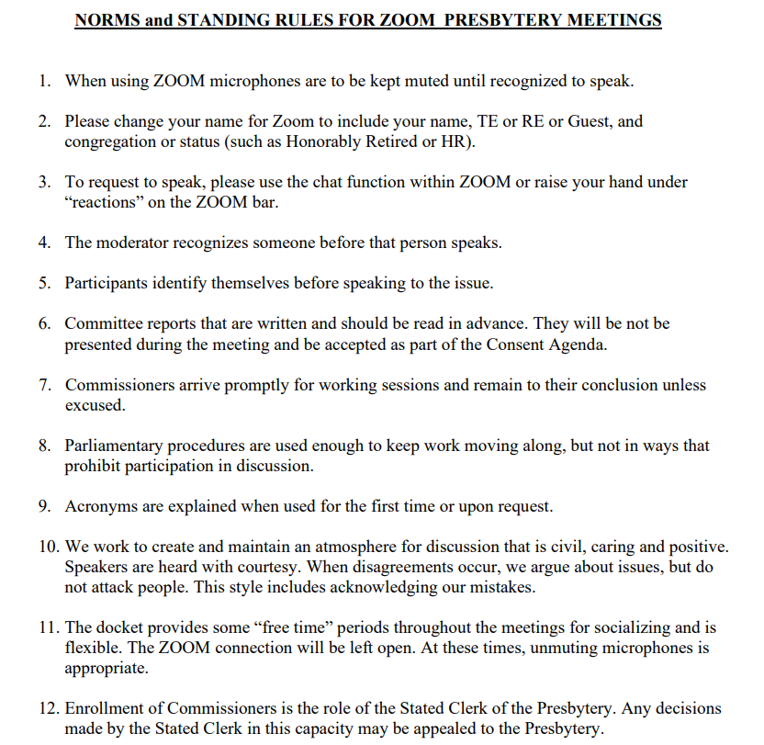
Figure 7: 2020 GA YAAD Report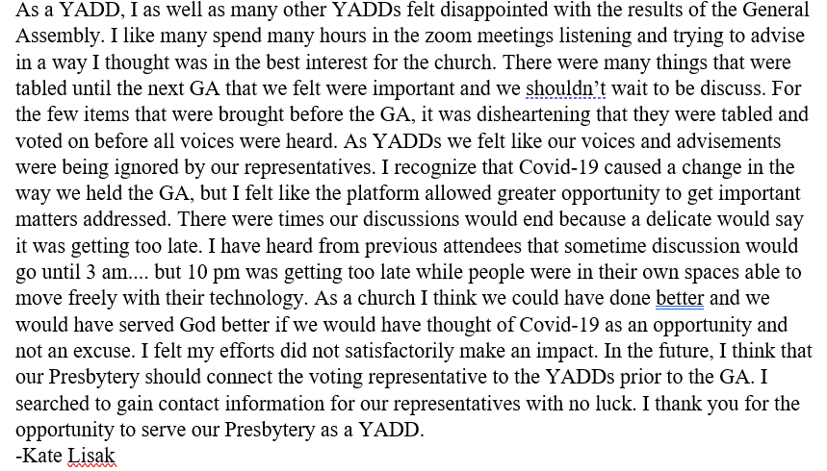

Figure 8: Consent Agenda page 1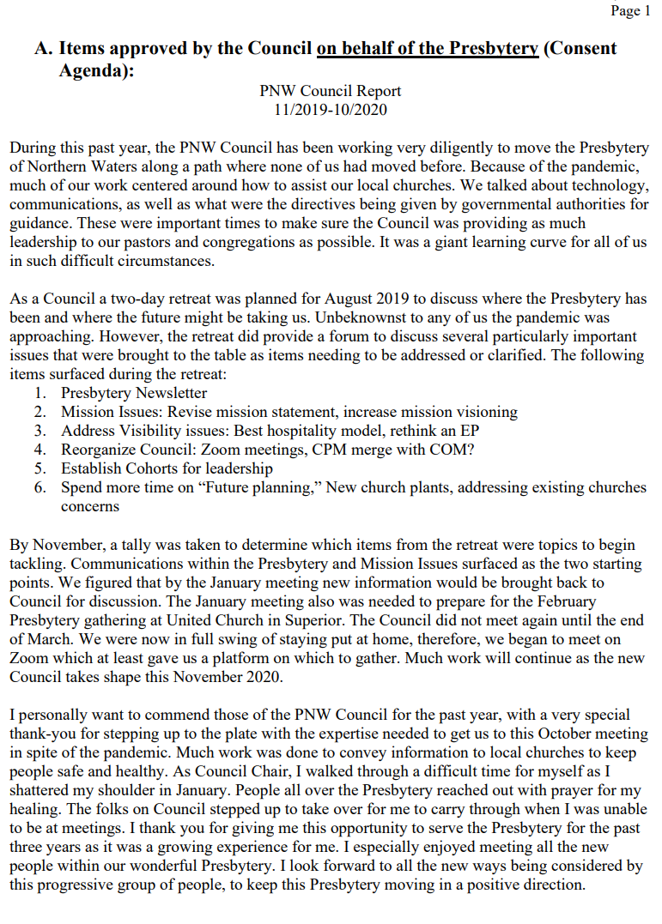

Figure 9: Consent Agenda page 2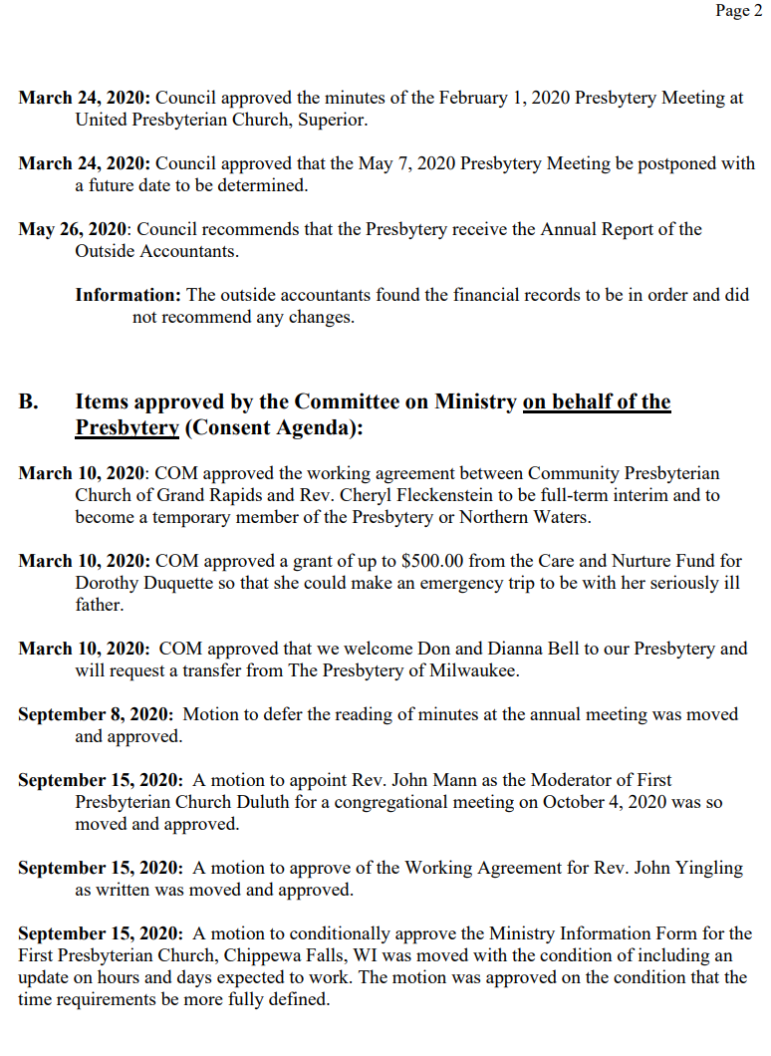
Figure 10:Consent Agenda page 3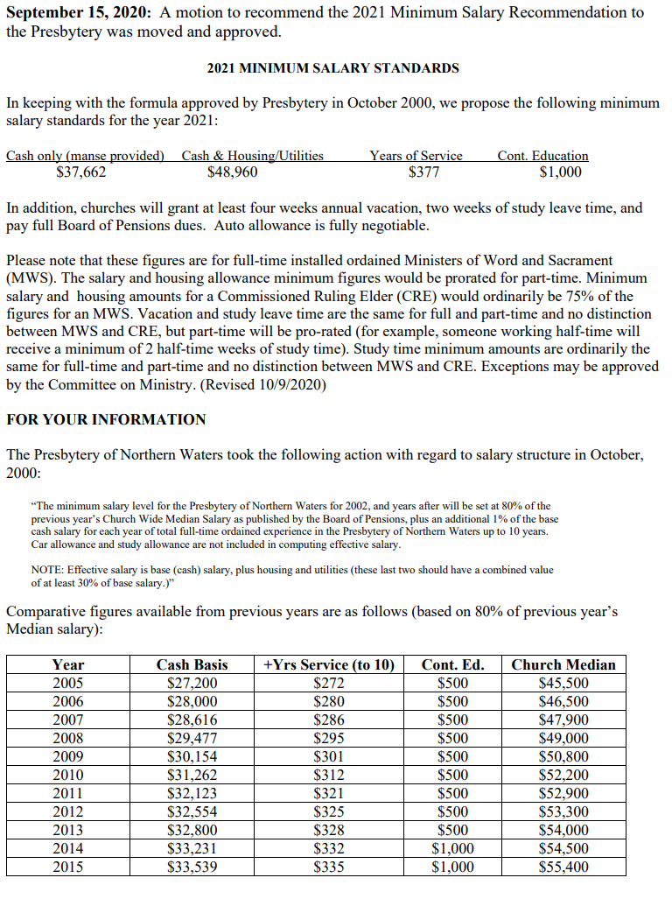
Figure 11: Consent Agenda page 4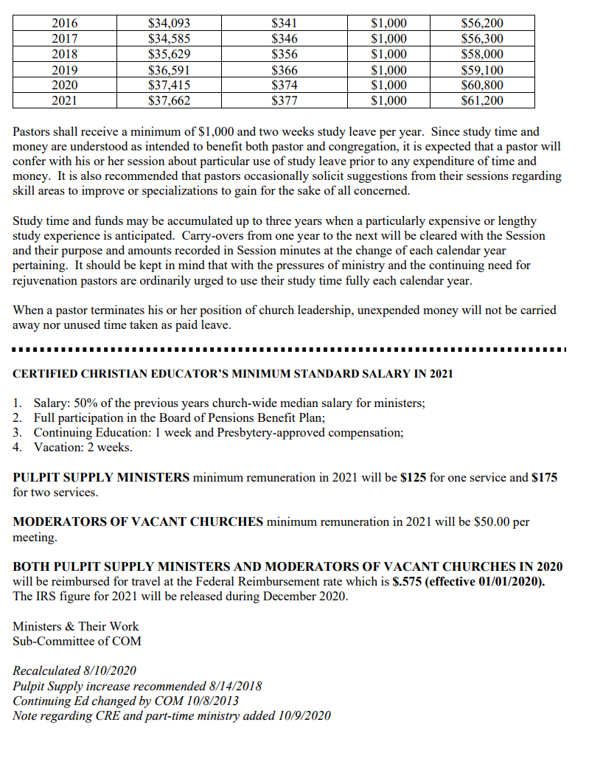
Figure 12: Consent Agenda page 5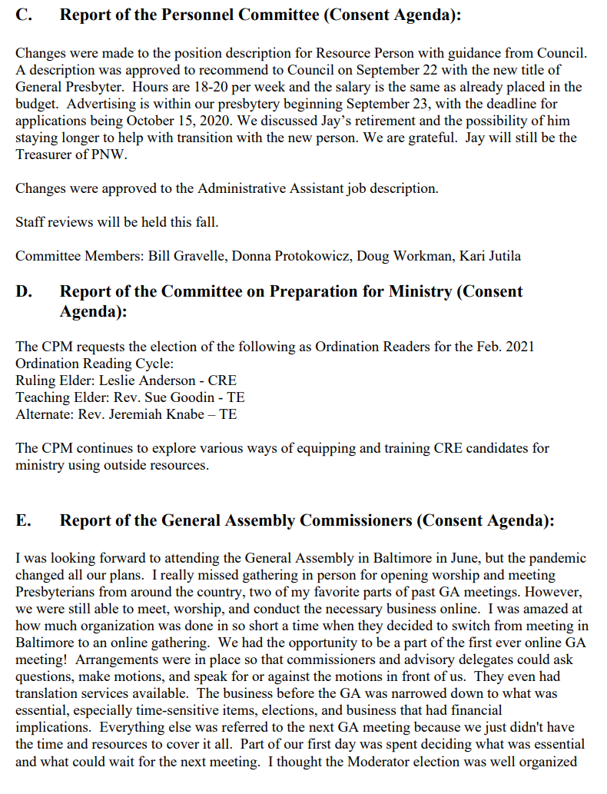
Figure 13: Consent Agenda page 6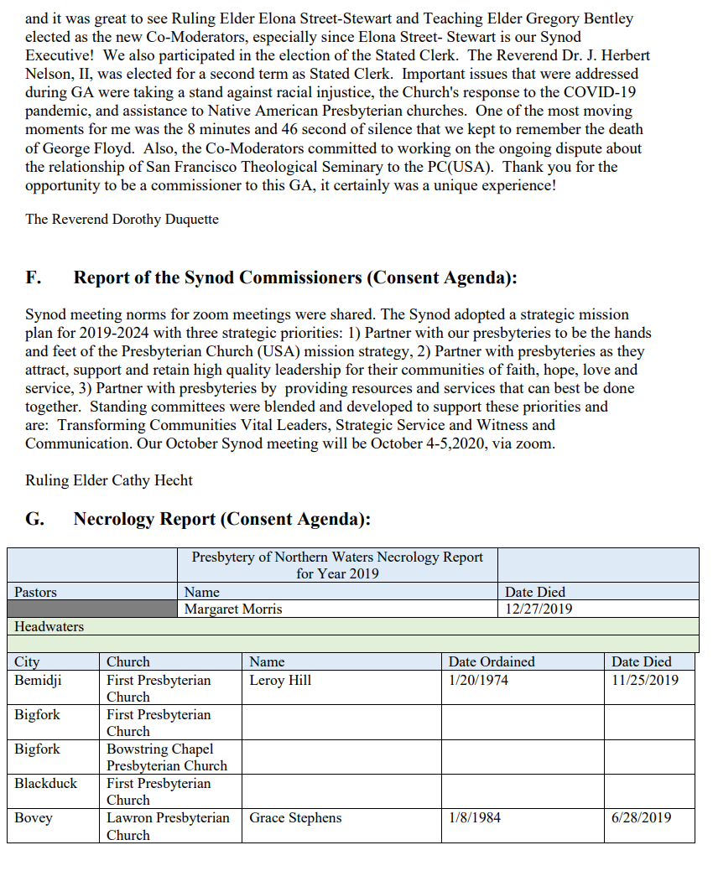
Figure 14: Consent Agenda page 7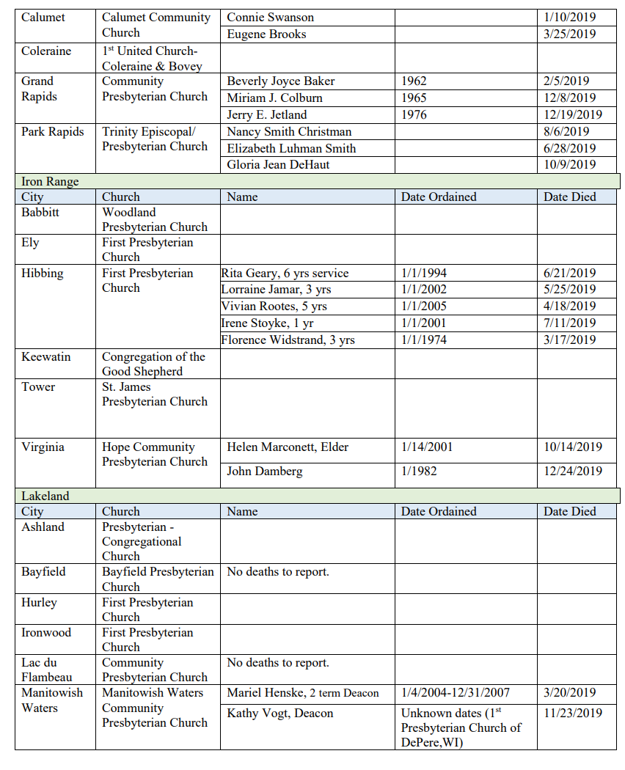
Figure 15 : Consent Agenda page 8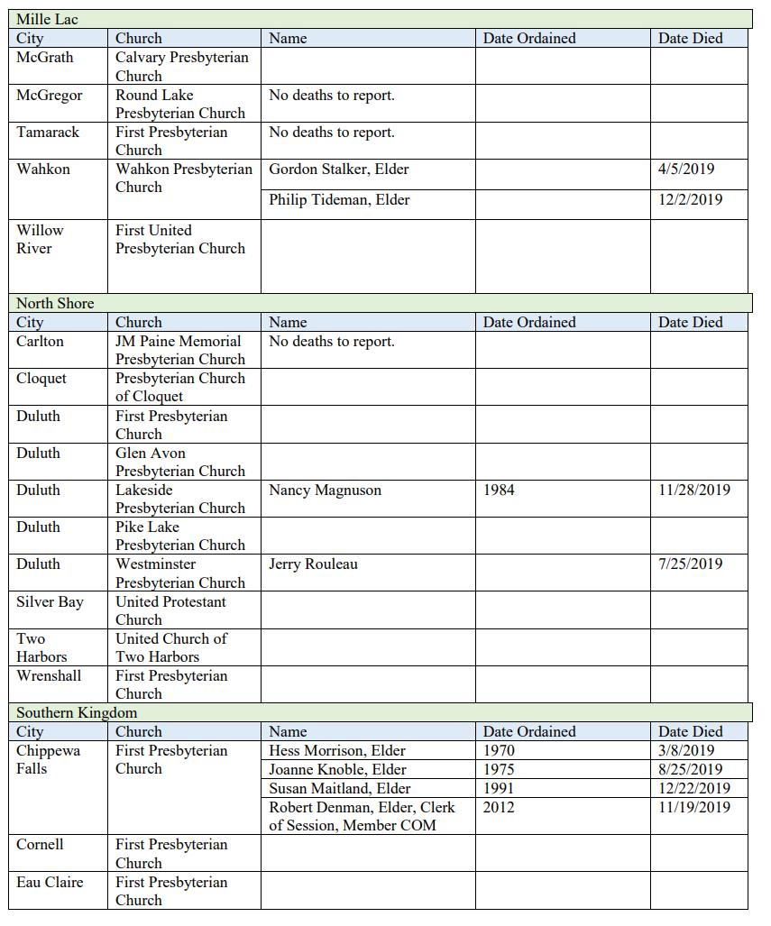
Figure 16: Consent Agenda page 9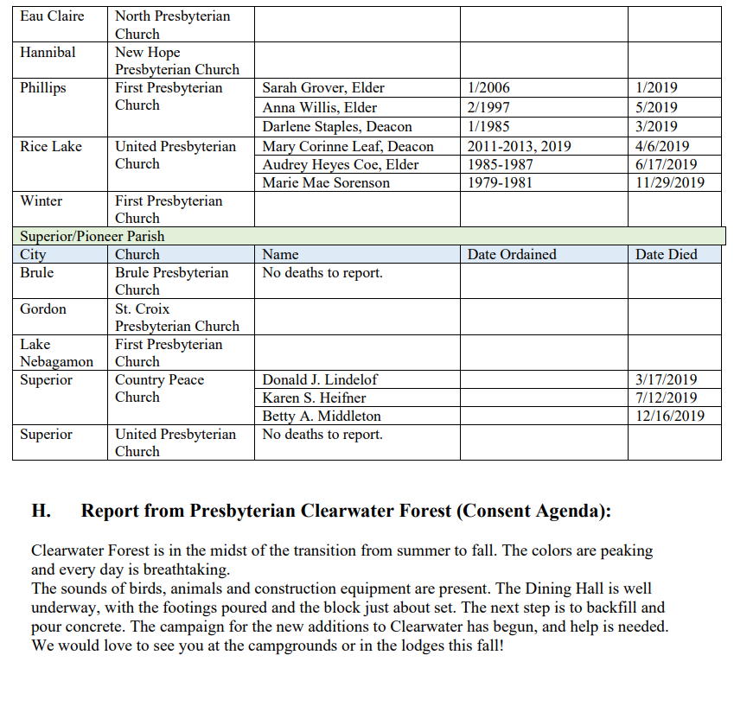

Figure 17: Consent Agenda page 10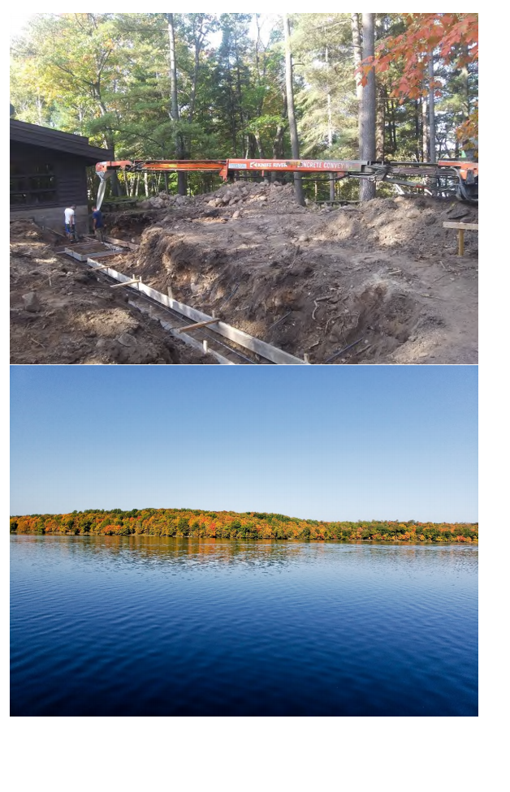
Figure 18:Recommendation to Dissolve the pastoral relationship of Rev. Jeremiah Knabe & First Presbyterian Church of Duluth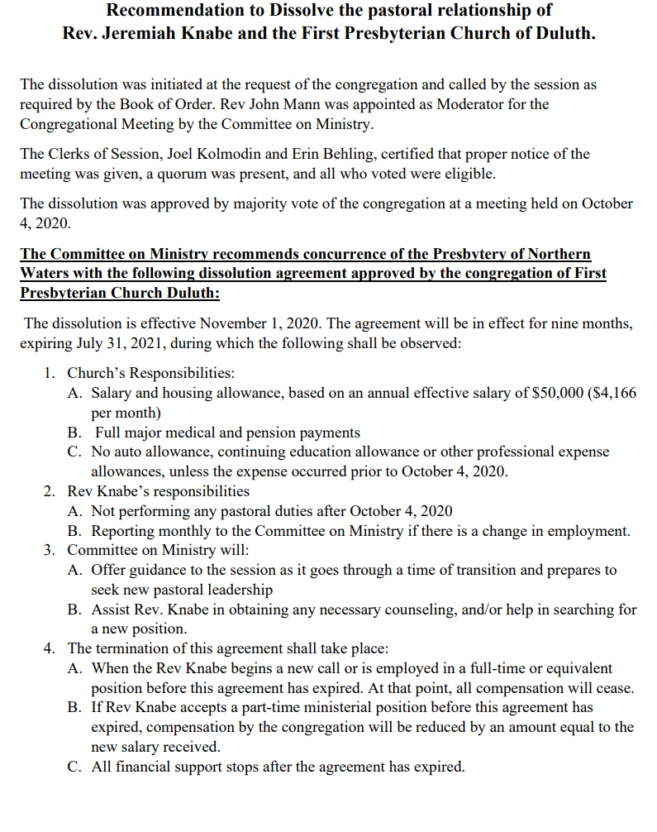
Figure 19: Motion for Creation of an Administrative Commission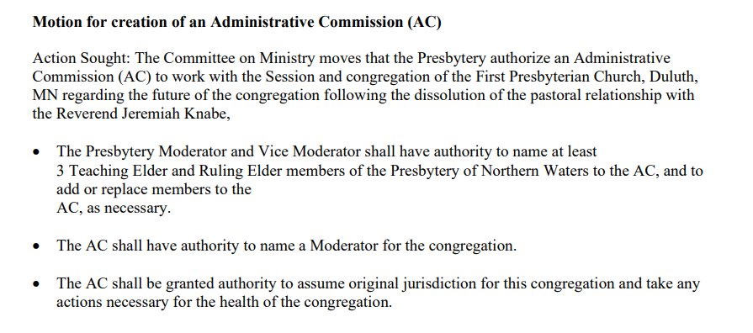
Figure 20: Finance and Budget Report
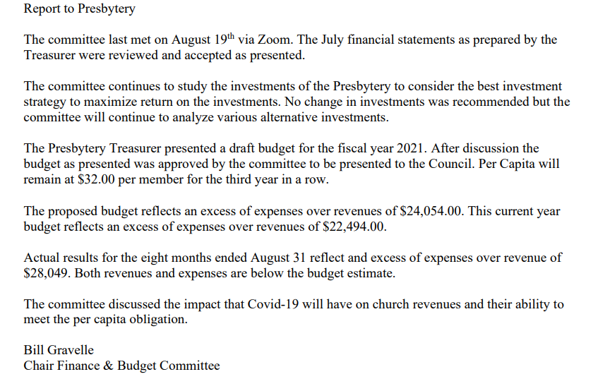
Figure 21:Independent Accountant's Review Report page 1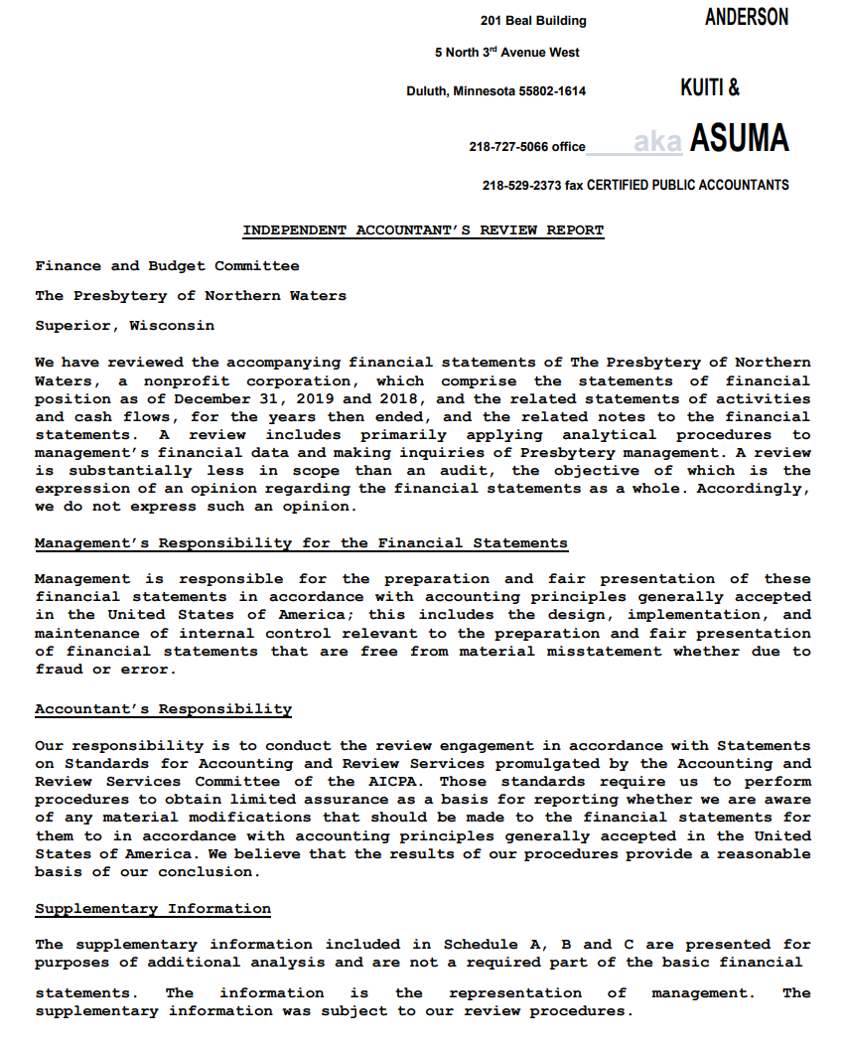
Figure 22: Independent Accountant's Review Report page 2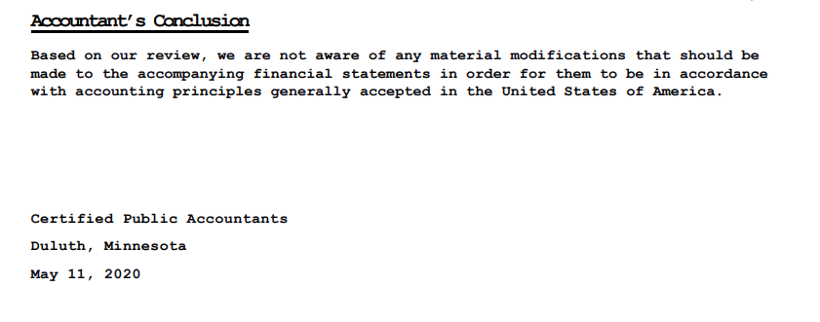
Figure 23: Independent Accountants Review Report page 3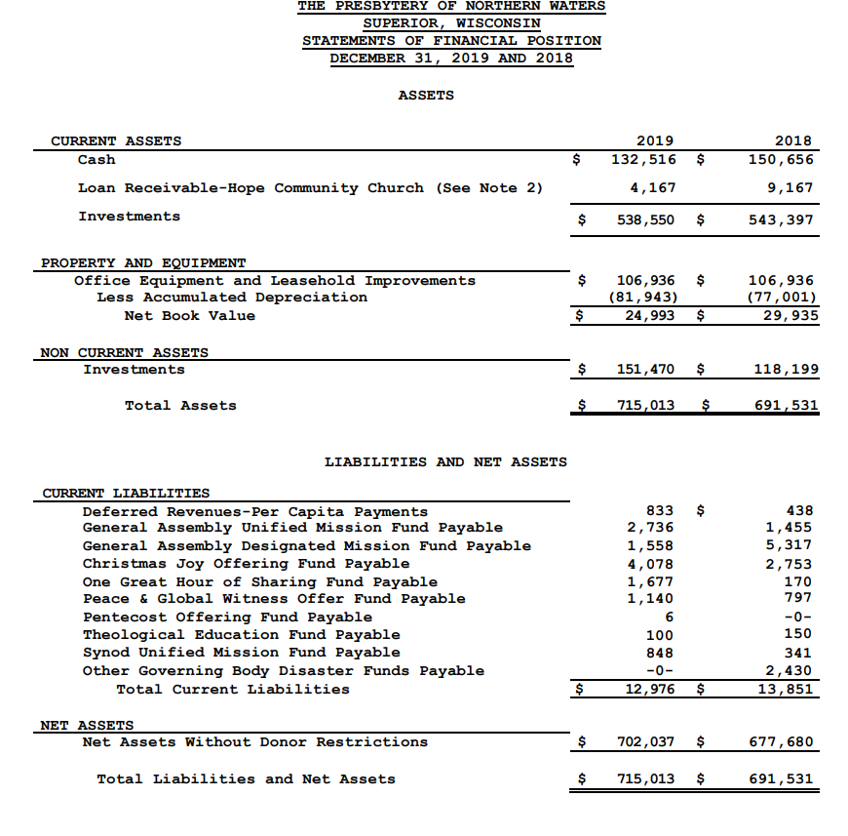

Figure 24: Independent Accountant’s Review Report page 4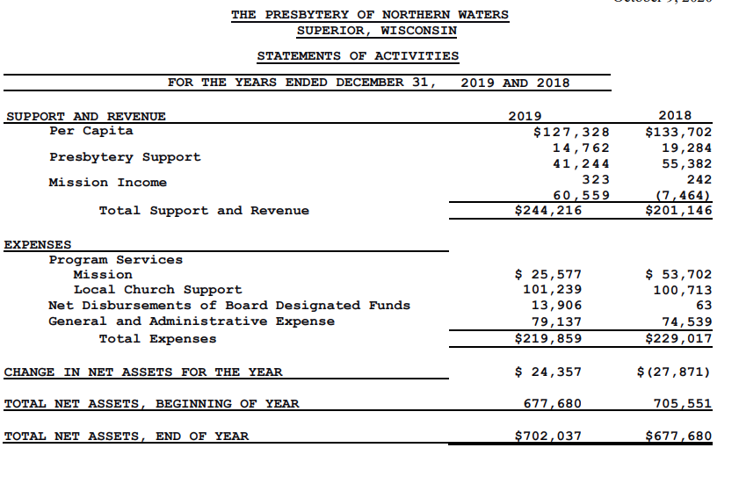

Figure 25: Independent Accountant's Review Report page 5
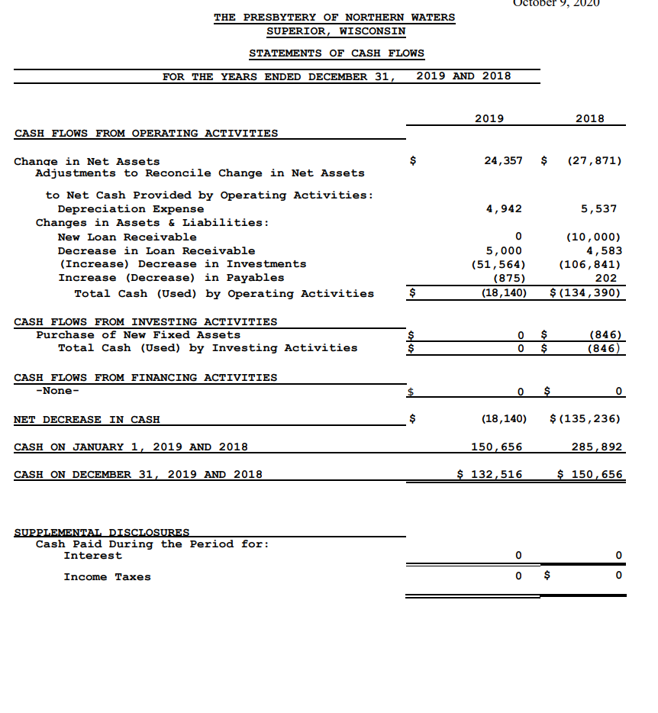
Figure 26: PNW Statement of Activities Ending 8/31/2020
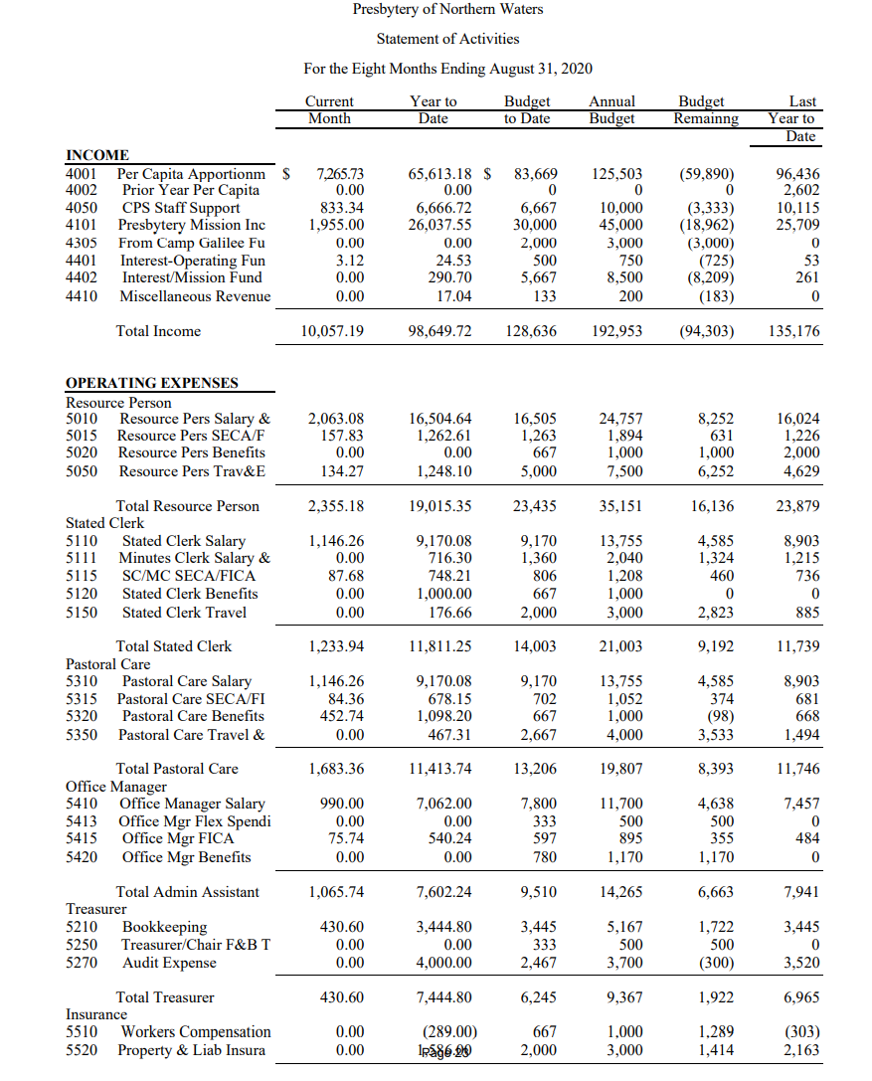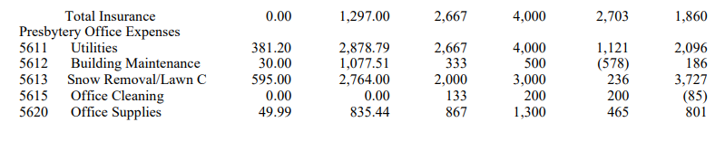
Figure 27: PNW Statement of Activities … Ending 8/21/2020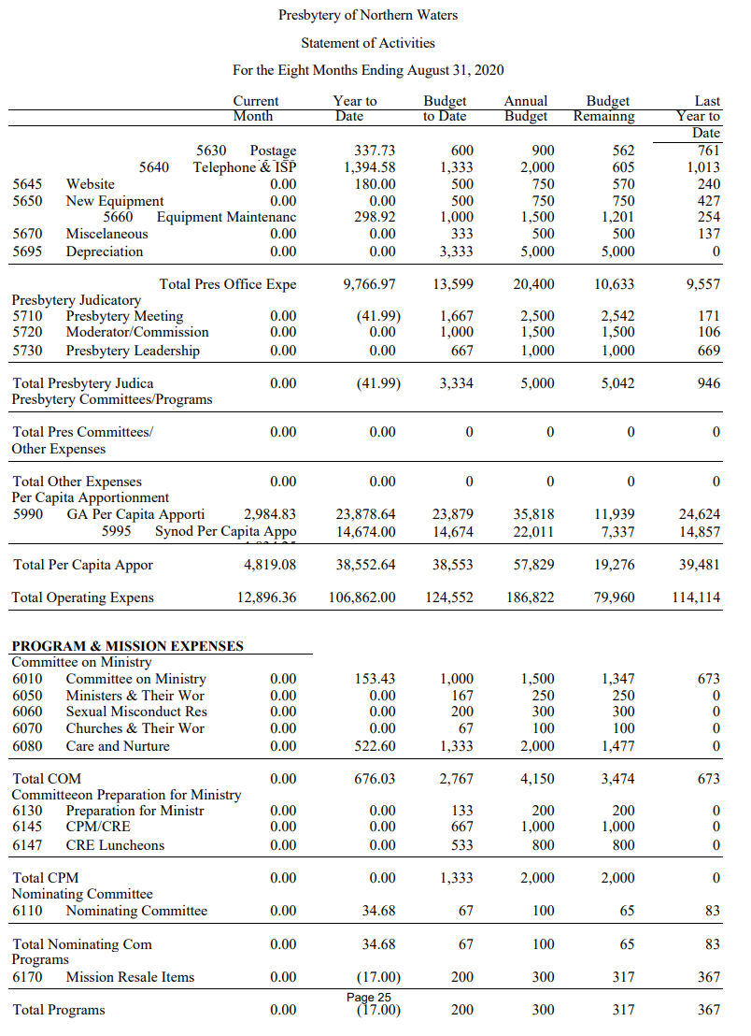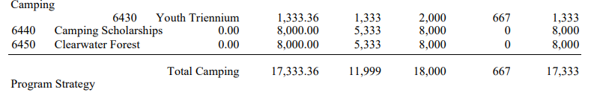
Figure 28:PNW Statement of Activities ... Ending 8/31/2020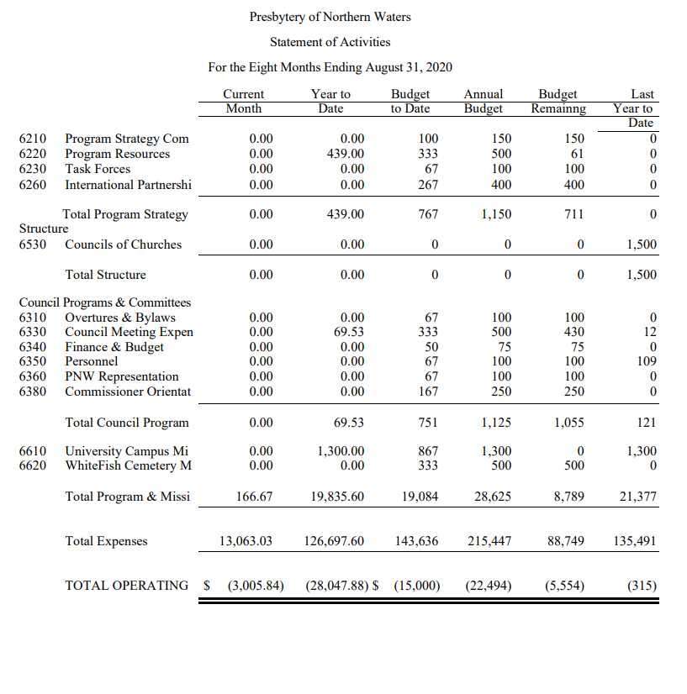
Figure 29: PNW Budget Worksheet page 1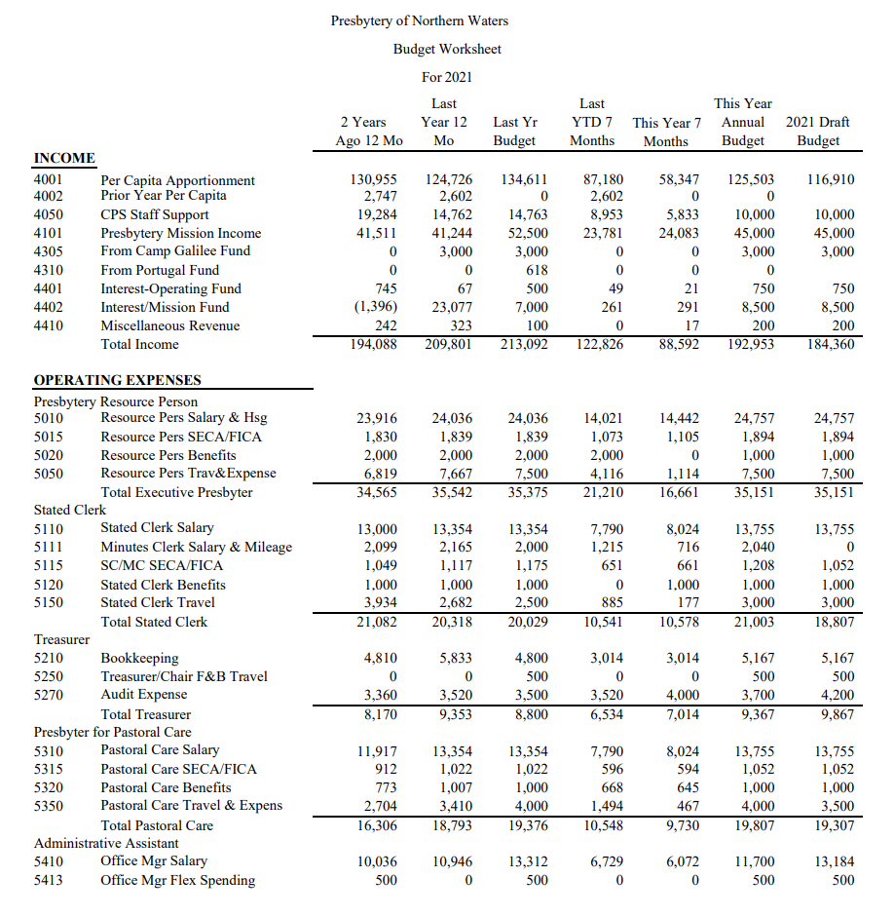
Figure 30:PNW Budget Worksheet page 2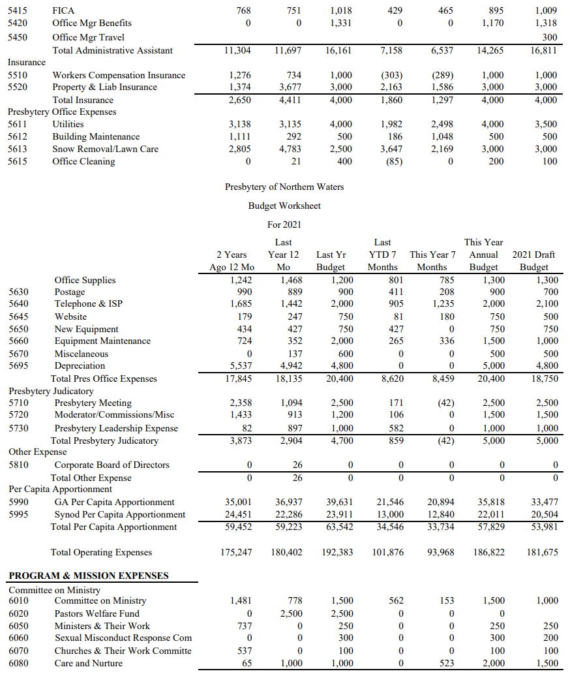
Figure 31: PNW Budget Worksheet page 3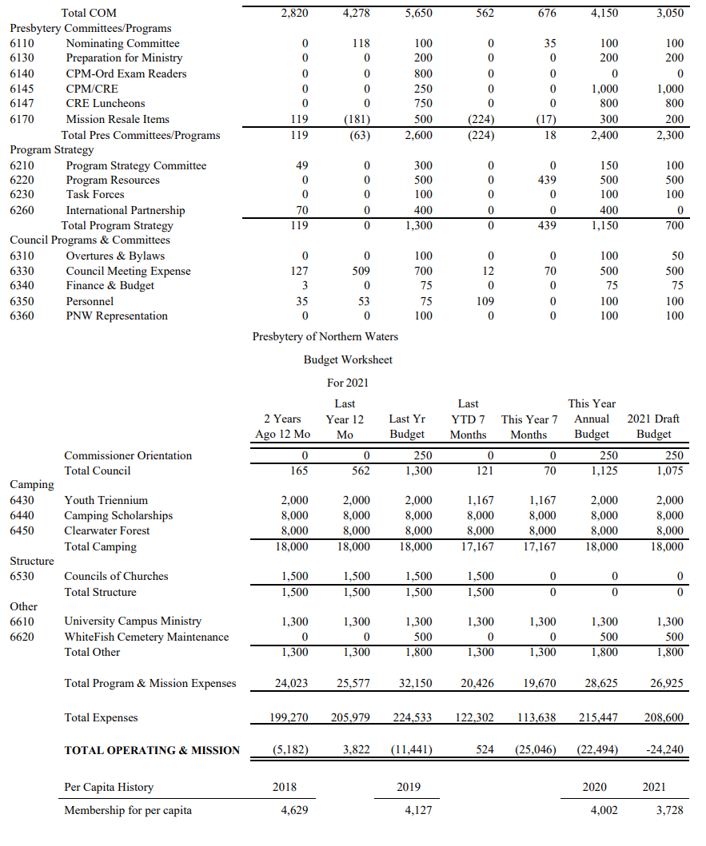
Figure 32: PNW Budget Worksheet page 4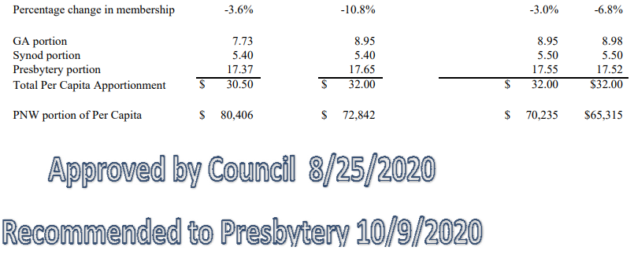
Figure 33: Nominating Committee Report page 1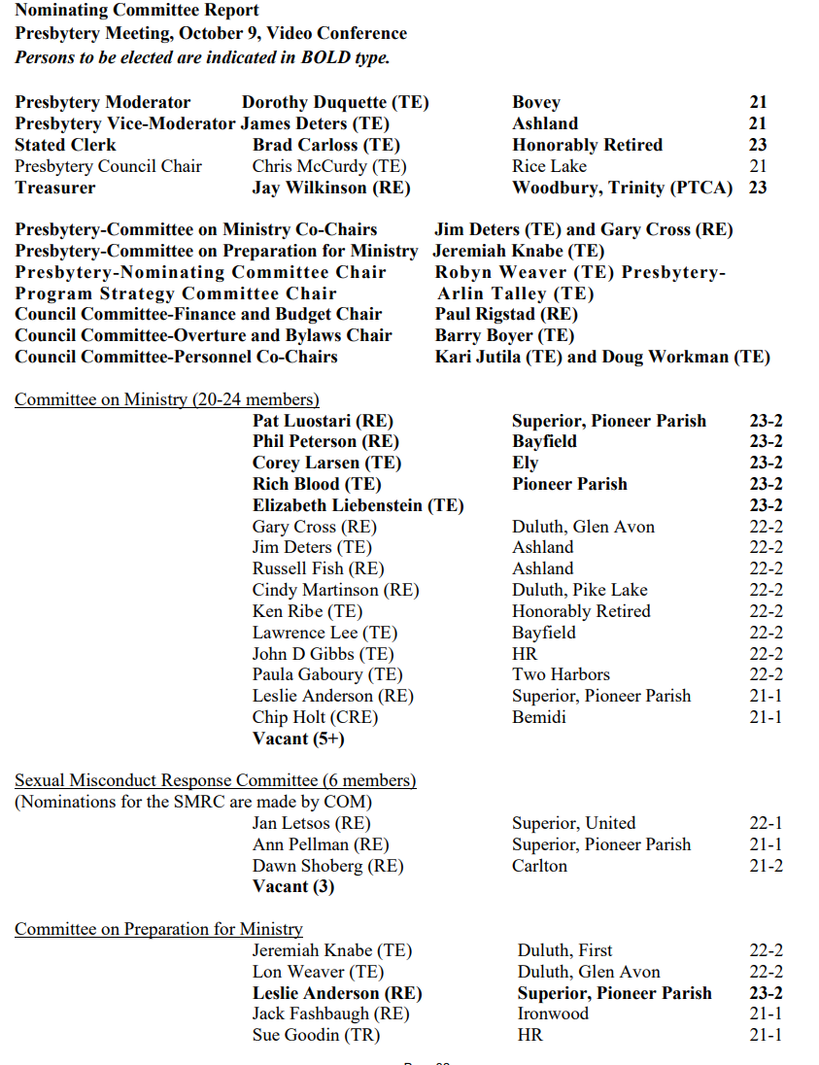
Figure 34: Nominating Committee Report page 2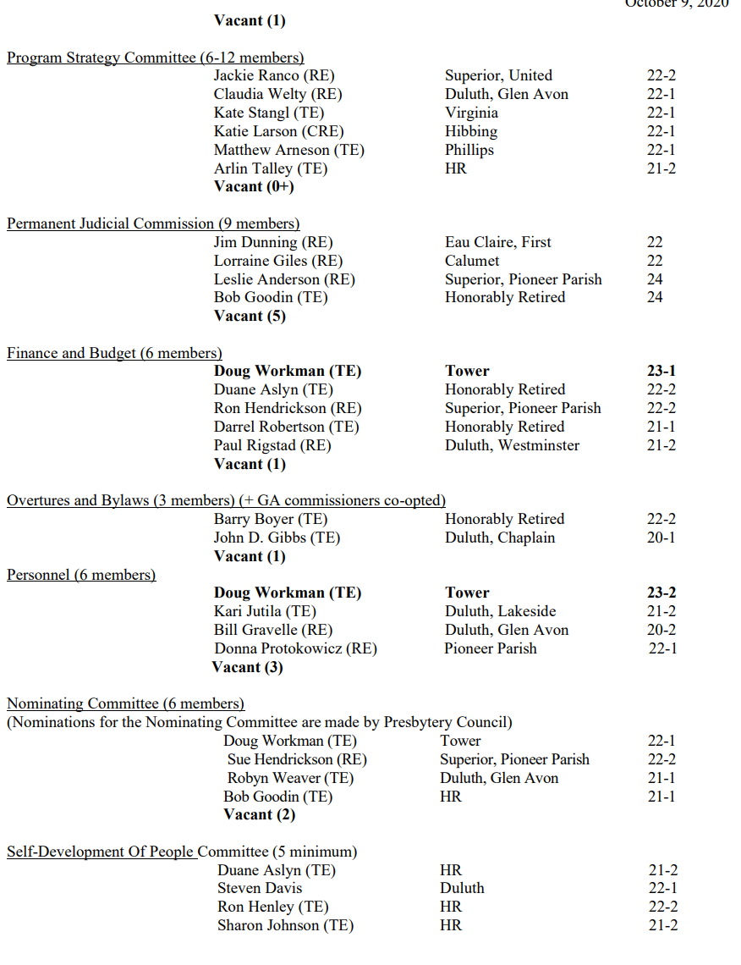
Figure 35: Nominating Committee Report page 3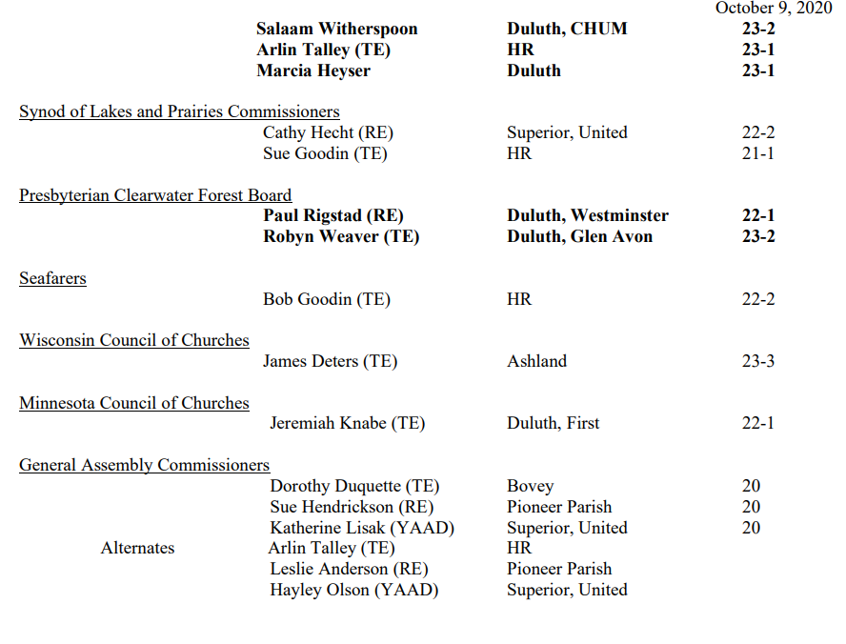
Figure 36: Worship and Installation page 1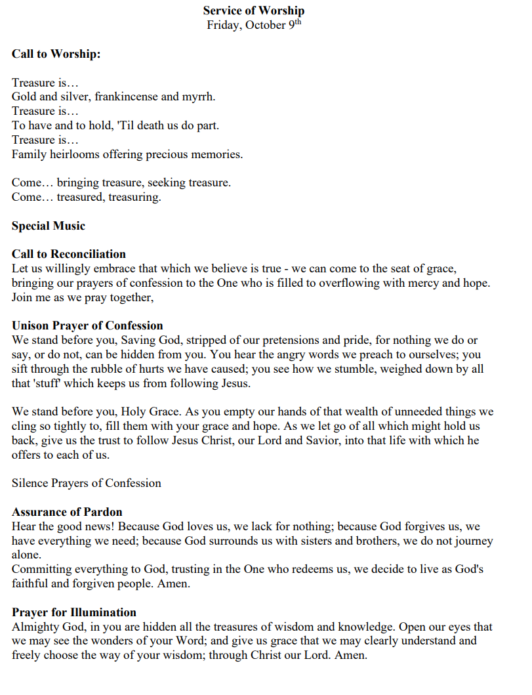
Figure 37: Worship and Installation page 2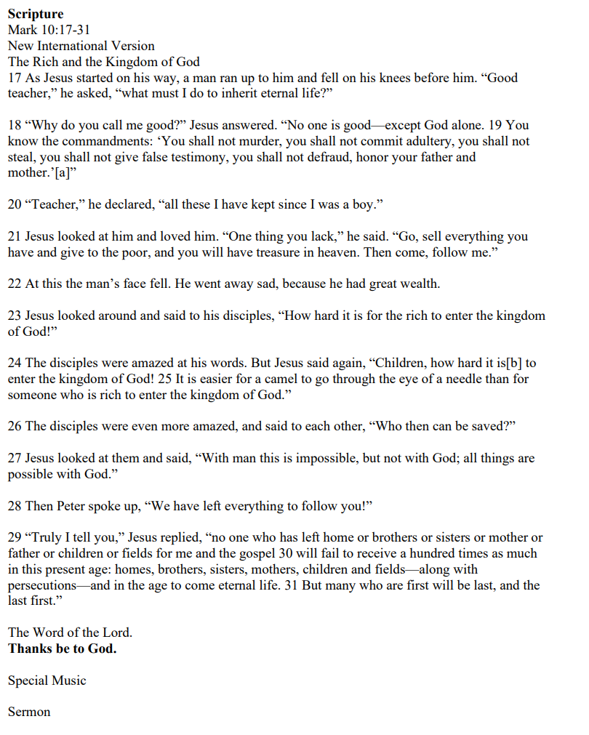
Figure 38: Worship and Installation page 3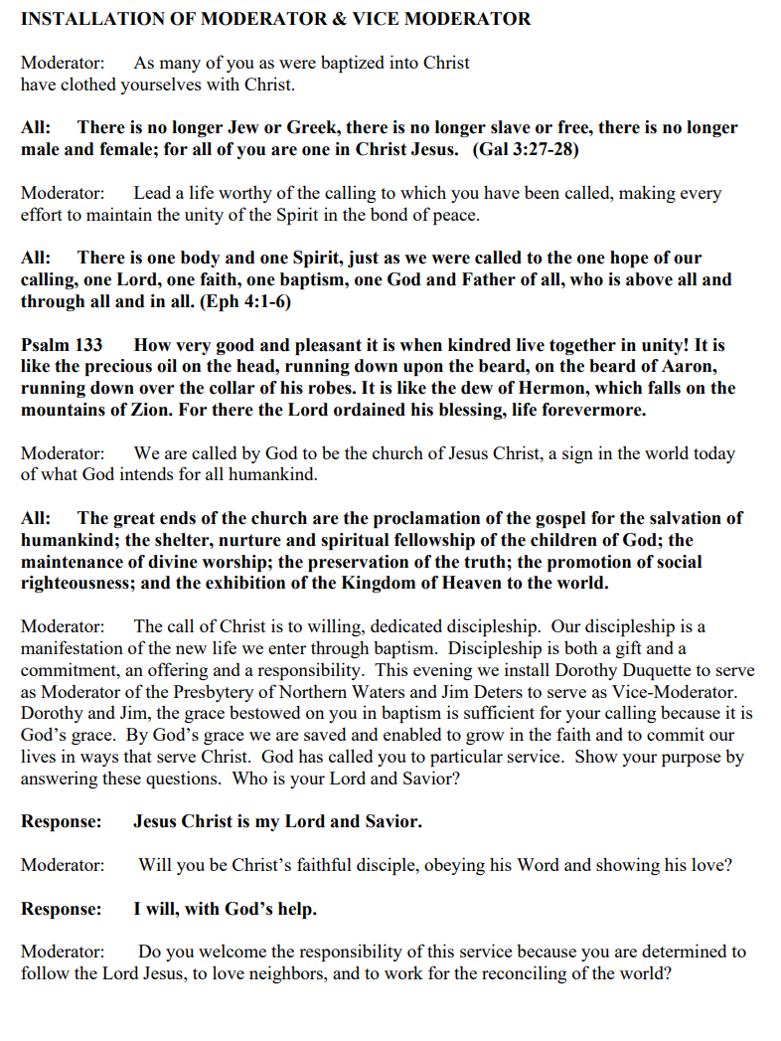
Figure 39: Worship and Installation page 4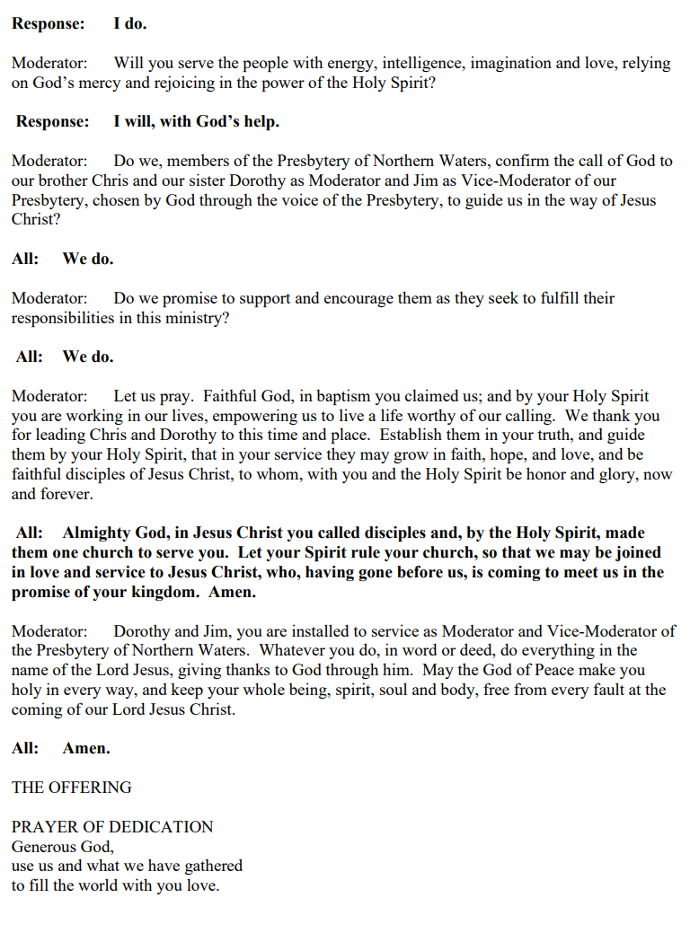
Figure 40: Worship and Installation page 5

